**Department of**

**ELECTRONICS AND COMMUNICATION ENGINEERING**

TARAS 2k20

**A National Level Technical Symposium**

**On**

**15th February 2020**

SOUVENIR

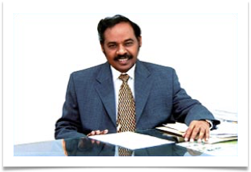

**Dr. T.R. Paarivendhar, B.Sc.,MIE**

Founder and Chancellor

SRM Group of Institutions

**MESSAGE**

To embark on a journey of success one needs the tools of preparedness, foresight, strategy and exposure to practical approach. These lead to the path of growth and high quality operation of the students. I am proud that the **Department of Electronics and Communication Engineering**, Valliammai Engineering College has organized a National level Technical Symposium on **15th February 2020**.

Success is achieved only through hard work and knowledge. This is a timely move that would pave the way for students to reach excellence and success in the field of electronics.

I wish all success for the symposium and hope it kindles the curiosity of the young minds which would lead to the growth of knowledge and creativity, ultimately leading to greater advancements in the field of electronics and also the success of the individual. I also take immense pleasure in appreciating the sincere efforts taken by the organizers and I wish them to reap the maximum from this symposium.

**Dr.T.R.Paarivendhar**

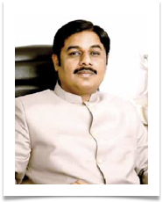

**Thiru. Ravi Pachmoothoo, M.A.,**

Chairman

SRM Group Of Institutions

**MESSAGE**

As the name says, **TARAS 2k20** is a festival celebrating the advancements in technology. I am sure that this symposium on **15th February 2020** is going to be a technical take off and a successful flight in innovation. Advancements in **Electronics and Communication Engineering** hints on a positive prosperity of not only the engineering field and also the betterment to the lives of mankind itself.

May the team of ‘**TARAS 2k20**’ hit great heights of fulfilling accomplishments. I extend my warm wishes to all those who worked behind the scenes for the prosperity of this symposium and they may reach great heights of success.

**Thiru. Ravi Pachmoothoo**

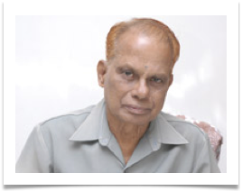

**Dr. T.P. Ganesan,**

Director, SRM Valliammai Engineering College

**MESSAGE**

It gives me immense pleasure to note that the Department of **Electronics and Communication Engineering** of SRM Valliammai Engineering College is organizing a National Level Technical Symposium on “**TARAS 2k20**” on **15th February 2020** at SRM Valliammai Engineering College.

I congratulate the Organizing Chairs, Principal &Vice Principal, Convener and Head of the Department of ECE, the Co-Convener and the various committee members of **TARAS 2k20.**

I wish the National Level Technical Symposium a grand success.

**Dr.T.P.Ganesan**

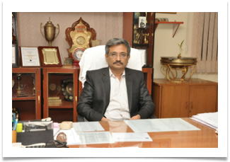

**Dr. B. Chidambararajan, M.E., Ph.D**

Principal

SRM Valliammai Engineering College

**MESSAGE**

**“TARAS 2k20”** is an idea of bringing the students together to share, to develop and to get exposed both technically and intellectually to the practical use of electronics and their applications in a competitive environment.

I am happy to witness the arrangements done by the team. I hope the symposium would be a sound platform for the students for exchange of ideas and implementation of newness in technical inspiration.

I wish the students of department of **Electronics and Communication Engineering** to experience fulfillment at **TARAS 2k20**. Let this gathering sow the seeds of innovation and knowledge in the minds of the students.

**Dr. B. Chidambararajan**

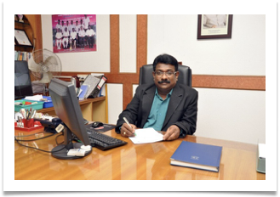

**Dr. M. Murugan, M.E., Ph.D**

Vice Principal

SRM Valliammai Engineering College

**MESSAGE**

Advances in Communication Technology has revolutionized the country’s Telecommunications in the last two decades. Seamless communication is now realistic and affordable in wired and wireless transmission modes.

In this context, it is aspiring to note that Department of **Electronics and Communication Engineering** of SRM Valliammai Engineering College, SRM Nagar, Kattankulathur, Chennai-603203 is arranging a one day “**National level technical symposium, TARAS 2k20”** on Saturday, **15th February 2020.**

I congratulate excellent work put in by organizing team members of Department of Electronics and Communication Engineering. I am convinced that the symposium will be valuable to all the participating students from various institutes across the country.

I once again **applaud the symposium organizers** and wish them a grant success.

**Dr. M. Murugan**

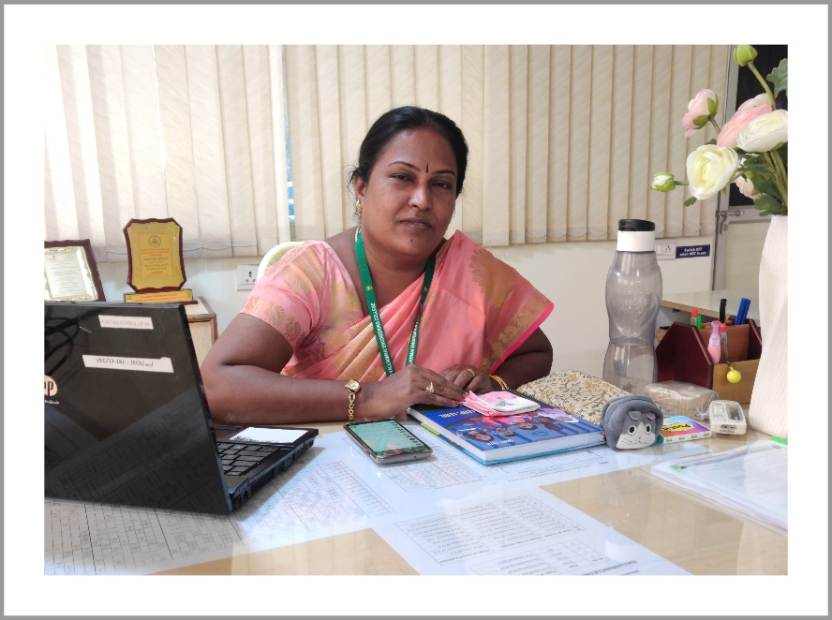

**Dr. Komala James, M.E., Ph.D**

Professor & Head of the Department

Electronics and Communication Engineering

**MESSAGE**

I thank our Management, Principal and Vice Principal for permitting and supporting us to conduct the symposium **“TARAS 2k20”** on **15th February 2020**. I am very happy to note that our students are working very efficiently with lot of interest and enthusiasm for the successful conduct of the event. Within a very short time span, there is lot of response from the participants.

I take this opportunity to congratulate the co-oordinators of the event **Ms.K.Arthi & Mr. M.A.Seenivasan** Assistant Professors of our departmentand the members of the various committees who have provided the necessary guidance, help and co-operation for the successful conduct of the symposium. I congratulate the office bearers President - **Mr.S.Sathya Narayanan**, Secretary -**Ms.B.Subhiksha**, Treasurer - **Mr.A.S.Aravind** , Program Executive -**Ms.Nikitha.K ,** the organizers of all the events and the members of the variouscommittees **of TARAS 2k20** team for their tremendous efforts and hard work.

I thank the judges of the various events for accepting our invitation and gracing the occasion. I thank the almighty God for showering the blessings on all of us and making this event a memorable one.

**Dr.Komala James**

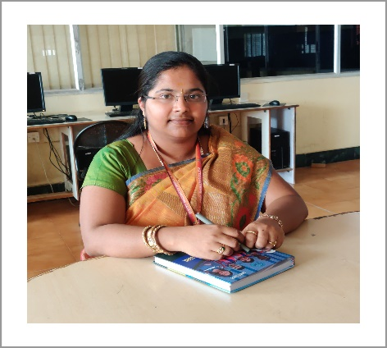

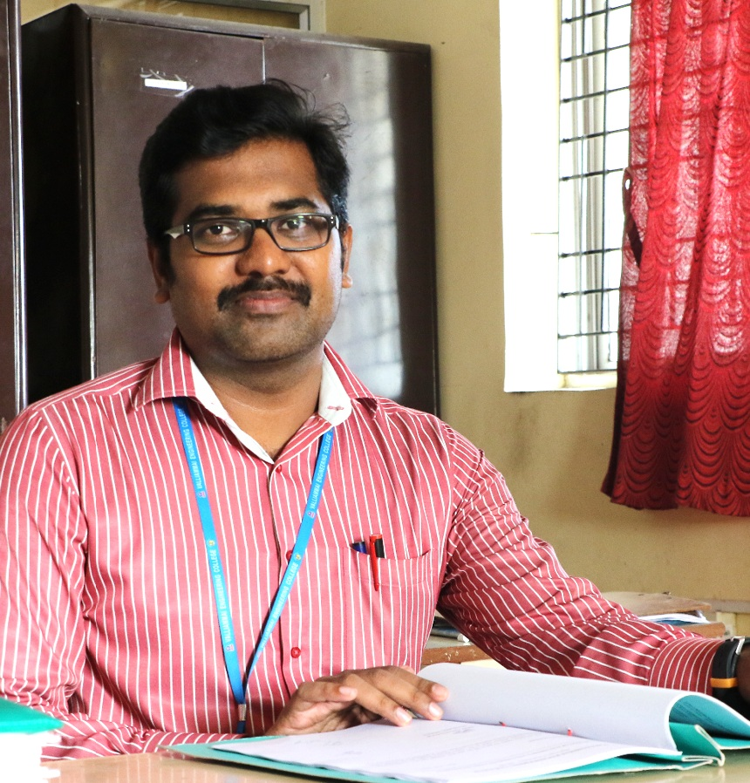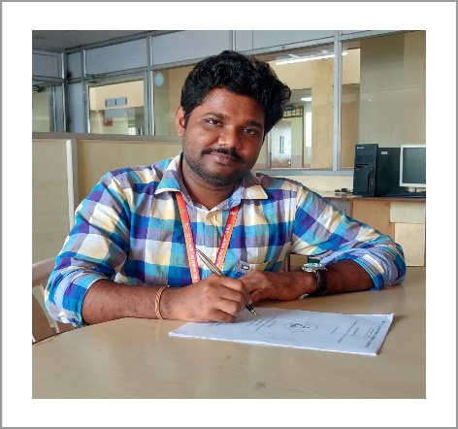

**Ms.K.Arthi Mr.M.A.Seenivasan**

Assistant Professor (O.G) Assistant Professor (O.G)

ECE Department ECE Department

**MESSAGE**

It gives us an immense pleasure to welcome all the delegates and invites to the National level Symposium **TARAS 2k20** hosted by Electronics and Communication Engineering Department, a momentous event to our beloved students. This symposium will provide us an opportunity to interact with various academics institutions which will enable us to share our knowledge.

We hope that during several sessions, new ideas may take birth, seeds of future collaboration may be sowed and a better professional relationship may be created. Through this symposium the foundation arms to bridge the research endeavours taking place across the world and create a platform for knowledge sharing, tracing the development of new molecules from laboratory to market.

We wish **TARAS 2k20** a great success and wish all of you a very fruitful and enjoyable day.

Co-Ordinators

**Ms.K.Arthi, AP**

**Mr. M.A.Seenivasan, AP**